# Web UI Development Tasks

1. Users search page

I don’t think Tableau web page allows us to search addresses, the lowest level we can search is zip code area. (prove to me, if I am wrong) So will have to test two solutions to see which one works.

Solution 1:

Tableau + insert API

Solution 2:

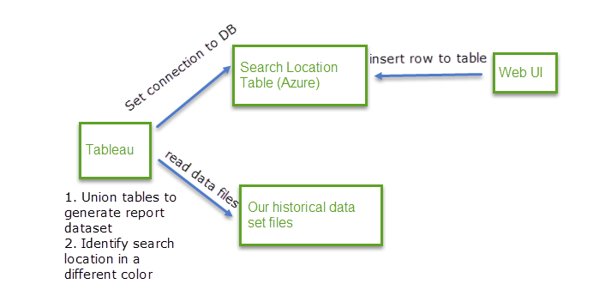

1. Study Azure (Cloud)

Create table on database on Azure

Make the web page talk to the database

Set connection between tableau and database

1. Create data layers

Display Hail data layer (Mock score data)

Display Wind data layer (Mock score data)

Display Tornado data layer (Mock score data)

Display Building data layer (Mock score data)

Display radar map layer (API)

Display satellite map layer (API)

Integrate layers

1. Coloring

Display different areas by different colors through table/scores

Display given location dot a different color through table/flag column

1. Data source refresh

When data changes, the system should trigger Tableau to reload data source

1. User feedback

Discuss with Kevin (client) to make sure it meets the business requirements

We can’t develop a perfect application in a day. If we can’t make some of the features, those can be implemented in the further ☺

# Reference:

# How to add map background from Mapbox

<https://www.youtube.com/watch?v=VJTraH2AeAA>

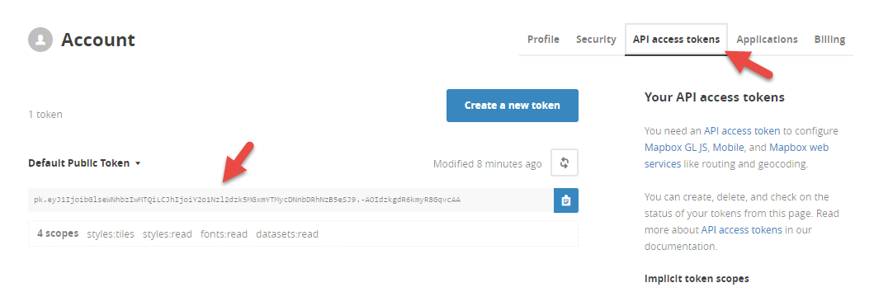

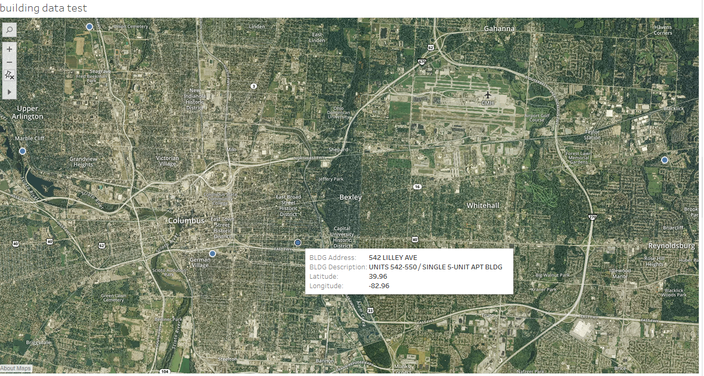

# how to draw a line between start and end points

<https://www.youtube.com/watch?v=96Pa1kSJDHM>

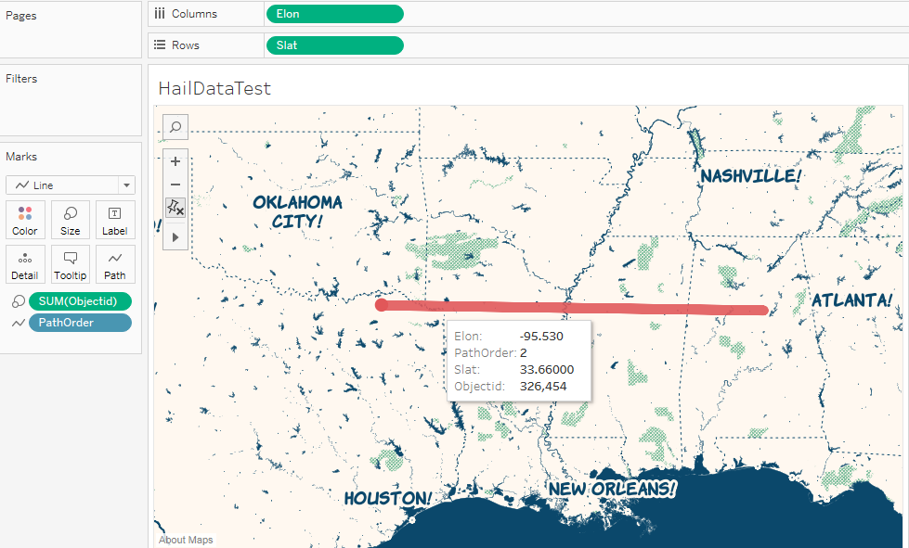

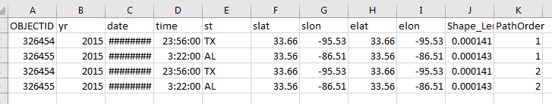

# How to add radar map background

<https://www.interworks.com/blog/ccrouch/2016/03/22/storm-chasing-tableau-how-create-weather-map>

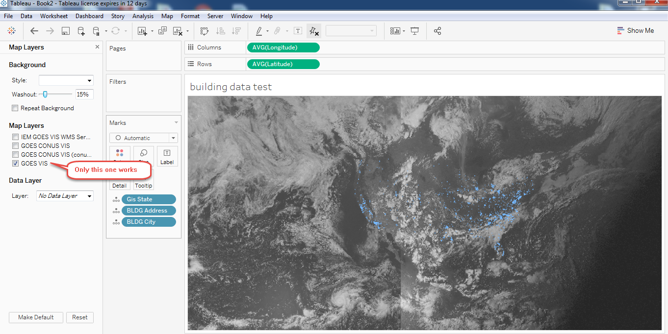

# Example workbook to download

<https://public.tableau.com/profile/melward#!/vizhome/SouthLondonMaps/CCGs>

